Registration ID: 260640160209
PNR: 260740150018
Name: PRATIK SUNIL ABHANG

Q1. Difference Between TCP and UDP
TCP and UDP are two important transport-layer protocols used to send data between devices. The main difference is that TCP focuses on reliable delivery, while UDP focuses on speed and low overhead.
TCP | UDP
Transmission Control Protocol | User Datagram Protocol
Connection-oriented | Connectionless
Reliable delivery | Delivery is not guaranteed
Data is kept in order | Packets may arrive out of order
Uses acknowledgements and retransmission | Normally does not use retransmission
Slower because of extra control | Faster with less overhead
Examples: web browsing, email, file transfer | Examples: DNS, online games, live streaming

Example: When downloading an important file, TCP is useful because missing data can be retransmitted. For a live video call, UDP is often preferred because speed is more important than retransmitting every lost packet.

Q2. Types of Network Cables
Network cables carry data from one device to another. The three common types are twisted-pair, coaxial, and fiber-optic cables.
Cable Type | Simple Description | Common Use
Twisted Pair | Copper wires twisted into pairs. UTP and STP are common types. | Ethernet networks in homes, offices and labs
Coaxial | Central copper conductor with insulation and shielding. | Cable TV and some older network systems
Fiber Optic | Uses light through optical fiber to carry data. | High-speed and long-distance communication

- UTP: Unshielded Twisted Pair — cheaper and commonly used.
- STP: Shielded Twisted Pair — has extra shielding to reduce interference.
- Fiber optic is very fast and is not affected by electromagnetic interference.

Q3. Types of Computer Networks
Computer networks can be classified by the area they cover.
Type | Full Form | Coverage | Example
PAN | Personal Area Network | Very small area around one person | Phone connected to earbuds using Bluetooth
LAN | Local Area Network | Home, office, school or lab | Computers connected in a computer lab
MAN | Metropolitan Area Network | City or large metropolitan area | Network connecting offices across a city
WAN | Wide Area Network | Countries or continents | The Internet

Easy idea: PAN is for one person, LAN is for a building or small area, MAN covers a city, and WAN covers a very large area.

Q4. Types of Casting
Casting means converting a value from one data type to another. In programming, the two basic types are implicit casting and explicit casting.
Type | Meaning | Example
Implicit Casting | The programming language automatically converts the value. | int a = 10; float b = a;
Explicit Casting | The programmer manually converts the value. | float a = 10.5; int b = (int)a;

Example explained: In explicit casting, converting 10.5 to int gives 10 because the decimal part is removed.

Q5. Networking Devices
Networking devices are hardware devices that connect computers and other devices and help data move through a network.
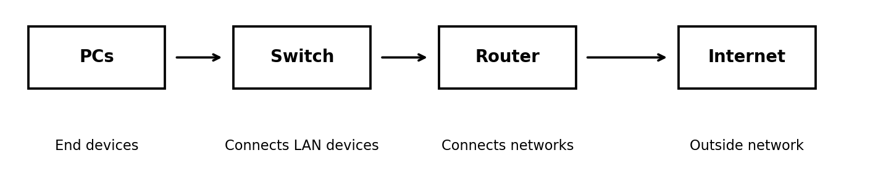
Device | Main Function | Simple Example
Hub | Sends incoming data to all connected devices. | Small/older LANs
Switch | Sends data to the correct device using MAC addresses. | Office or computer lab LAN
Router | Connects different networks and forwards packets using IP addresses. | Home router connecting a LAN to the Internet
Modem | Converts signals so a network can communicate with an ISP connection. | Home broadband connection
Repeater | Regenerates a signal to extend its range. | Extending a network signal
Bridge | Connects and filters traffic between network segments. | Connecting two LAN segments
Gateway | Acts as an entry/exit point between networks, sometimes using different protocols. | Connecting a local network to another network
Wireless Access Point | Provides Wi-Fi access to devices. | Wi-Fi access point in an office

Q6. OSI Model
OSI stands for Open Systems Interconnection. It is a seven-layer reference model that explains how data travels between computers over a network.
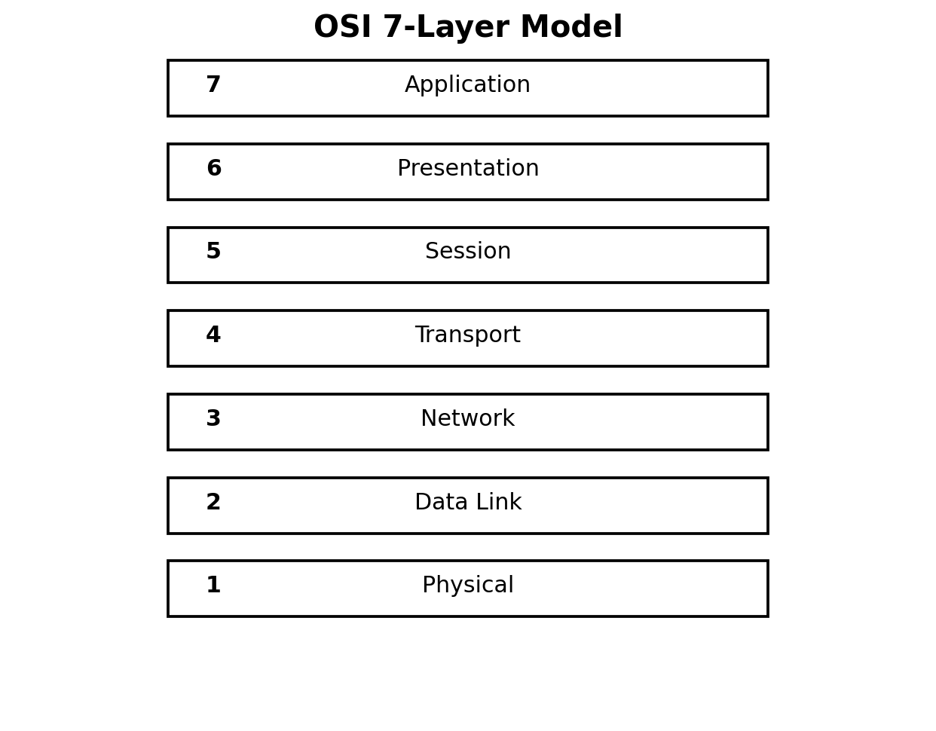
Layer | Name | Main Function | Simple Example
7 | Application | Provides network services to applications. | Web browser, email application
6 | Presentation | Handles data format, encryption and compression. | Data formatting/encryption
5 | Session | Starts, manages and ends communication sessions. | Maintaining a communication session
4 | Transport | Provides end-to-end delivery, flow control and reliability. | TCP/UDP
3 | Network | Handles logical addressing and routing. | IP addressing and routers
2 | Data Link | Handles frames, MAC addresses and error detection. | Ethernet / switches
1 | Physical | Transmits raw bits through physical media. | Cables, radio signals

